PROJECT DOCUMENTATION

**STAGE PLAN**

| **Project:** | **E-Commerce Website for SKANDA**  **by Sarasi Samarasinghe.** |
| --- | --- |
| Release: | April 2022 |
| Date: | 3rd March 2022 |
|  |  |
| **PRINCE2** |  |
|  |  |
| Author: | M. Sonali Silva, S. K. Helani Sihara Jayawardena |
| Owner: | Dr Yasas Jayaweera (Project Executive) |
| Client: | Mrs Sarasi Samarasundara. |
| Document Ref: | StagePlan_SKANDA |
| Version No: | 1.0 |

# 1 Stage Plan History

## 1.1 Document Location

This document is only valid on the day it was printed.

The source of the document will be found on the project's PC in location

## 1.2 Revision History

**Date of this revision: 03/03/2022**

**Date of Next revision:**

| **Revision date** | **Previous revision date** | **Summary of Changes** | **Changes marked** |
| --- | --- | --- | --- |
| 03/03/2022 |  | First issue |  |

## 1.3 Approvals

This document requires the following approvals.

Signed approval forms are filed in the Management section of the project files.

| **Name** | **Signature** | **Title** | **Date of Issue** | **Version** |
| --- | --- | --- | --- | --- |
| Dr Yasas Jayaweera |  | Project Board | 03/03/2022 | 1.0 |
| Adithya Narasinghe |  | Project Manager | 03/03/2022 | 1.0 |
| Mrs. Sarasi Samarasundara |  | Client | 03/03/2022 | 1.0 |

## 1.4 Distribution

This document has been distributed to:

| **Name** | **Title** | **Date of Issue** | **Version** |
| --- | --- | --- | --- |
| Adithya Narasinghe | Project Manager | 03/03/2022 | 1.0 |
| M. Sonali Silva | Start-up Manager | 03/03/2022 | 1.0 |
| J. M. Pasindu Lawantha Bandara | Quality Manager | 03/03/2022 | 1.0 |
| Madapathage Don Kanishka Gimhan | Risk Manager | 03/03/2022 | 1.0 |
| S. K. Helani Sihara Jayawardena | Scheduling Manager | 03/03/2022 | 1.0 |

# 2 Table of Contents

**1 Stage Plan History** **2**

1.1 Document Location 2

1.2 Revision History 2

1.3 Approvals 2

1.4 Distribution 2

**2 Table of Contents** **3**

**Stage Plan** **4**

3 Purpose 4

4 Plan Description 5

5 Quality Plan 5

6 Plan Prerequisites 5

7 External Dependencies 6

8 Tolerances 6

9 Monitoring and Control 6

10 Reporting 7

11 Planning Assumptions 7

12 Graphical Plan 7

12.1 Gantt or Bar Chart 7

12.2 Product Breakdown Structure 7

12.3 Product Flow Diagram 7

12.4 Activity Network 8

12.5 Financial Budget 8

12.6 Resource Requirement Table 8

12.7 Risk Assessment 8

13 Product Descriptions 8

# Stage Plan

## 3 Purpose

**Sprint 1**

This sprint starts on 02/28/2022 and ends on 03/13/2022. By the end of the sprint, there should be a deployed version of the website, with sample content that can be viewed by anyone with the URL. The following tasks need to be completed within this sprint: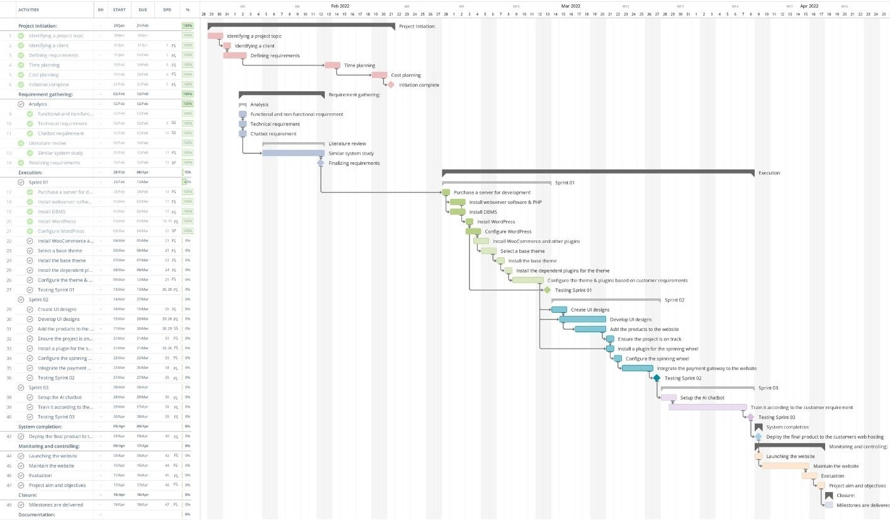

To progress on Sprint 1, a hosting plan should be purchased. In addition to that, a WordPress theme that supports WooCommerce should be purchased.

At the end of each day, the person responsible for the task should update the project manager on the status of the task. Based on the daily updates, the project manager has a complete overview of how the project is progressing. So, the project manager can easily intervene, when intervention is required.

The progress of the Sprint will be measured with comparison to the Gannt Chart. The schedule is created with a 5% headroom for each task. At the end of the sprint, the quality manager will test the completed product with a pre-determined set of test cases to evaluate the quality and completeness of the project.

**Sprint 2**

This sprint starts on 02/14/2022 and ends on 03/31/2022. By the end of the sprint, the following tasks need to be completed:

To begin sprint two, we should first complete and test sprint one. The person in charge of the job should inform the project manager of the task's status at the end of each day. Thanks to the regular updates, the project manager has a clear picture of how the project is progressing. As a result, the project manager can readily intervene as necessary. The progress of the sprint will be assessed by comparing it to the Gantt Chart. Each task in the timetable has a 5% headroom allowance. At the end of the sprint, the quality manager will test the finished product with a pre-determined set of test cases to assess the project's quality and completeness.

**Sprint 3**

This sprint starts on 02/28/2022 and ends on 04/09/2022. By the end of sprint 3, the website should be completed, and the content should be accessible to everybody. During this sprint, the following tasks must be completed:

Moreover, based on the daily updates, the project manager has a complete overview of sprint 3. So, the project manager can easily intervene, when intervention is required. On the other hand, the progress of the Sprint will be measured in comparison to the Gannt Chart. The schedule is created with a 5% headroom for each task. The quality manager will test the final product with a pre-determined set of test cases at the end of the sprint to evaluate the project's quality and completeness.

## 4 Plan Description

The project plan aims to identify the valuable aspects, activities, and resources for the project. And also to provide a statement on how and when the project's objectives will be accomplished. It provides the business case with an evaluation of project expenses and management phases, including other significant control issues. It provides a starting point for the Project Board to track project improvement.

## 5 Quality Plan

“Quality Plan version 1.1” document is uploaded to the project's GitHub repository for documents (https://github.com/nmasnadithya/sppm) and it should be located in the Week 4 folder.

## 6 Plan Prerequisites

The plan assumes that all the requirements have been gathered and finalized. In addition, the budget has been finalized with the client. Similar systems need to be studied to get an idea of how other systems of this space function.

## 7 External Dependencies

The project heavily depends on the WordPress and WooCommerce platforms for the development of the e-commerce platform. In addition, the project relies on the shared hosting service provider to provide uninterrupted hosting during the development and after the deployment of the project.

The project heavily depends on the third-party payment gateway to reliably & securely handle the online transactions.

Finally, the project depends on Google Cloud Services & DialogFlow for the uninterrupted service of the AI-based chatbot, which is built using the above-mentioned technologies.

## 8 Tolerances

Tolerances are the limitations on how much you may change your project without having to resubmit it for approval. We may go a little over or under tolerance and not have to keep going back to our project sponsor to have any changes authorized. On the other hand, the project sponsor is in charge of choices that impact the project budget and schedule, and modifying will vary from the agreed-upon plan. Mrs. Sarasi Samarasundara has approved a budget of Rs. 150,000 with a 10% tolerance, which means we can spend up to Rs. 165,000 before having to seek approval for the increased spending. A time tolerance is when we can be behind or ahead of the schedule according to the project schedule dates. Due to the developers' commitments to their undergraduate project, work, and personal life, the clients were gracious enough to give an extra month for the full implementation on the condition that the project must not in any way be of low quality.

## 9 Monitoring and Control

The purpose of controlling a stage process is to assign tasks among team members to monitor it, which includes reporting stage status to the project board and taking required actions to confirm that the stage remains within tolerance as well.

The team meets once a week to review the project's progress and plan the tasks for the next week. Next, the project manager will use Trello to arrange the work based on the schedule manager's plans. Moreover, using the WhatsApp group, the completion of the allocated tasks are tracked. And also, all completed work packages are returned to the controlling stage, where they are received and evaluated again. In this stage, the schedule manager can ensure that the project is according to the scheduled plan.

## 10 Reporting

All the managers will inform the scheduling manager if the allocated time is insufficient. Upon their request, the scheduling manager will rearrange the schedule according to the flow of the project sprint and inform the project manager of the alterations.

On the other hand, if any project-related concerns arise, all team members will inform the project manager, who will provide the guidelines to follow. The issues and project status will communicate to the project board and the client.

## 11 Planning Assumptions

“Project Plan version 1.1” document is uploaded to the project's GitHub repository for documents (https://github.com/nmasnadithya/sppm) and it should be located in the Week 4 folder.

## 12 Graphical Plan

### 12.1 Gantt or Bar Chart

“Project Plan version 1.1” document is uploaded to the project's GitHub repository for documents (https://github.com/nmasnadithya/sppm) and it should be located in the Week 4 folder.

### 12.2 Product Breakdown Structure

“Project Plan version 1.1” document is uploaded to the project's GitHub repository for documents (https://github.com/nmasnadithya/sppm) and it should be located in the Week 4 folder.

### 12.3 Product Flow Diagram

### 

### 12.4 Activity Network

### 12.5 Financial Budget

### 

“Project Plan version 1.1” document is uploaded to the project's GitHub repository for documents (https://github.com/nmasnadithya/sppm) and it should be located in the Week 4 folder.

### 12.6 Resource Requirement Table

| ID | Type of resource | Resource details | Quantity |
| --- | --- | --- | --- |
| 1 | Machine | PC | 5 |
| 2 | Person | Team members | 5 |
| 3 | Person | Board member | 1 |
| 4 | Software | WordPress | 1 |
| 5 | Software | WooCommerce | 1 |
| 6 | Software | MySQL | 1 |
| 7 | Service | Zoom | 1 |
| 8 | Service | Google docs | 1 |
| 9 | Service | Payment Gateway | 1 |
| 10 | Service | Network connection | 5 |

### 12.7 Risk Assessment

“Project Plan version 1.1” document is uploaded to the project's GitHub repository for documents (https://github.com/nmasnadithya/sppm) and it should be located in the Week 4 folder.

## 13 Product Descriptions

“Product description version 1.0” document is uploaded to the project's GitHub repository for documents (https://github.com/nmasnadithya/sppm) and it should be located in the Week 4 folder.